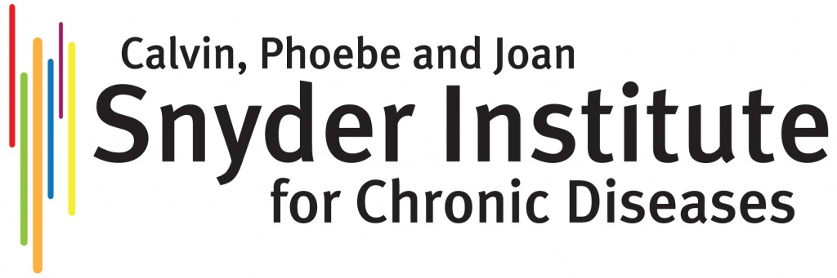

Joan Snyder Award for Gender Diversity in Research Excellence Nomination Form

THE NOMINATION FORM SHOULD BE SUBMITTED BY E-MAIL TO THE SNYDER EDUCATION COMMITTEE (snydered@ucalgary.ca) NO LATER THAN 11:59 PM ON MONDAY THE 29th OF SEPTEMBER 2025 AS INDICATED IN THE AWARD TERMS OF REFERENCE.

As a public body, the Snyder Institute of Chronic Diseases is regulated by the Freedom of Information and Protection of Privacy Act (FOIPP) of Alberta. As such, the information on this Personal Data page will be for internal use ONLY.

SECTION 1: Nominee Information

Name of Nominee: Surname, First Name
Eligibility:

Does the nominee belong to an equity-deserving gender group? - Please see definitions at the end of this document.

Yes

Contact Details:
E-mail:

SECTION 2: Nominator Information

Name of Nominator: Surname, First Name
Contact Details:

Phone:

E-mail:

SECTION 3: Statement of Nomination

Please provide a statement of nomination (maximum of 250 words) describing why the individual would be deserving of this award.

Definitions:

- Equity-deserving* gender groups: groups who have experienced attitudinal, historic, social and environmental barriers based on their sex at birth, gender identity and/or gender expression. This includes women, transgender individuals and non-binary individuals.
*Alternative terminology: Equity-Denied, Equity-Seeking
- Transgender: refers to people whose reported gender does not correspond to their reported sex at birth.
- Non-binary: refers to people whose reported gender is not exclusively man or woman. Herein, non-binary is used to describe all genders that are neither exclusively man nor woman, although individuals might self-identify with other terms.
- Women: refers to people who identify as women, this may or may not match their reported sex at birth.

Sources:

  - Equity & Inclusion Glossary of Terms. University of British Columbia Equity & Inclusion Office.
  - Canada Council for the Arts.
  - Statistics Canada. Accessed

